Linked Operation Intelligence Platform: Design Plan
Oct 22, 2026 · @Samarth

1. Purpose and scope
The platform takes data files from any number of factory operations, uses the upstream and downstream context supplied with them, and builds one linked view per engine. AI proposes the setup and code validates it, so no one reviews or approves a step. AI also explains the findings. Plain code does every join and every number.
An operation is one step on the line, identified by the plant's operation number. In the sample data, operation 10 is Top Cover Tightening and operation 20 is Leak Testing. They are linked: the same engine passes through both, in order, and a leak failure may be associated with how the engine was tightened.
How the setup works
- Supply context. Register a versioned operations.yaml once per line, with operation IDs, upstream and downstream links, and source time zones. Each upload uses that version. An upload without valid context is held; operation-number order alone never activates a production link.
- Map automatically. AI proposes how the file's columns map to the standard model. Code validates the proposal against the whole file and applies it only if every check passes.
- Standardize and commit automatically. The platform converts the data to one standard form. Rows that fail a rule go to a quarantine table with the reason, and the batch commits only if the quality gates pass.
- Generate the linked view. A link activates when its evidence checks pass, and only active links produce a join, following the rules in section 6. Impact analysis follows the same links.
In scope
- Read each operation's context and links from the context supplied with the files.
- Map, standardize and load files automatically, with validation and quality gates instead of approvals.
- Generate a linked view per group of connected operations. Operations with no active link stay standalone.
- Find which upstream measurements are associated with downstream failures.
- Chat and option buttons to ask about any operation or the linked view.
Out of scope for the first version
- Live machine connectivity (files only), user accounts, multi-plant support and write-back to machines.
- Predictive models. Findings are statistical associations, never causes.

2. What the sample file tells us
The only fixture is the 30-day, 3,000-engine file: 1 to 30 September 2026, 100 engines a day, two operations. It is synthetic.
 | Operation 10 | Operation 20
Name | Top Cover Tightening | Leak Testing
Sheet | Tightening Station | Leak Testing Station
Machine ID | NUTRUNNER-01 | LEAKTEST-01
Rows | 3,090 (3,000 engines plus 90 retries) | 3,000
Attempt column | Yes | No
Measurements | Bolt 1 and Bolt 2 torque against 15 to 18 Nm | Leak rate against 5 sccm
Results | 90 engines fail attempt 1 and pass attempt 2 | 720 NOK, 2,280 OK
What the file contains. Only engines whose final tightening attempt passes reach the leak test. The transfer time from the end of the final tightening to leak-test entry is 2 minutes for 80% of engines, 1 minute for 10%, over 2 to 10 minutes for 8% and over 10 to 30 minutes for 2%. A Linked View sheet joins the two operations on Engine No.
Patterns seeded in the file. 360 leak failures come with an uneven bolt torque (difference above 2.0 Nm while both bolts stay in range) and 300 with a delayed cycle start (over 15 s). 60 failures have no seeded cause. A torque difference above 2.0 Nm picks out exactly the 360, and a start delay above 15 s picks out exactly the 300. None of the 2,280 passing engines or the 60 unexplained failures crosses either line. The 90 engines that needed a retightening fail the leak test at about 24%, the same as the overall rate, so rework does not look associated with leak failures.
Cautions for the build
- Answer columns. Failure Code, Suspected Cause, Tightening Correlation, Seeded Scenario, Hypothesis Assessment and Hypothesis Basis on the Linked View sheet are pre-written conclusions. Do not ingest them. Keep them only as an answer key.
- Untitled columns with stray values. The tightening sheet has two untitled columns (O and P) holding one stray character each in row 8. The profiler must flag columns like these and the pipeline must ignore them without help.
- One machine per operation. Machine ID is loaded as resource_id, but with one machine each the platform cannot yet rank machines. The test data needs a second machine first.
- No drift over time. The daily leak failure rate moves between 14% and 36% with no trend, so alerts on drift cannot be tested with this file.
- Unexplained failures exist. The platform must report the 60 failures that no upstream factor explains.
- Leak threshold of 5 sccm is a placeholder, per the Read Me.

3. Architecture
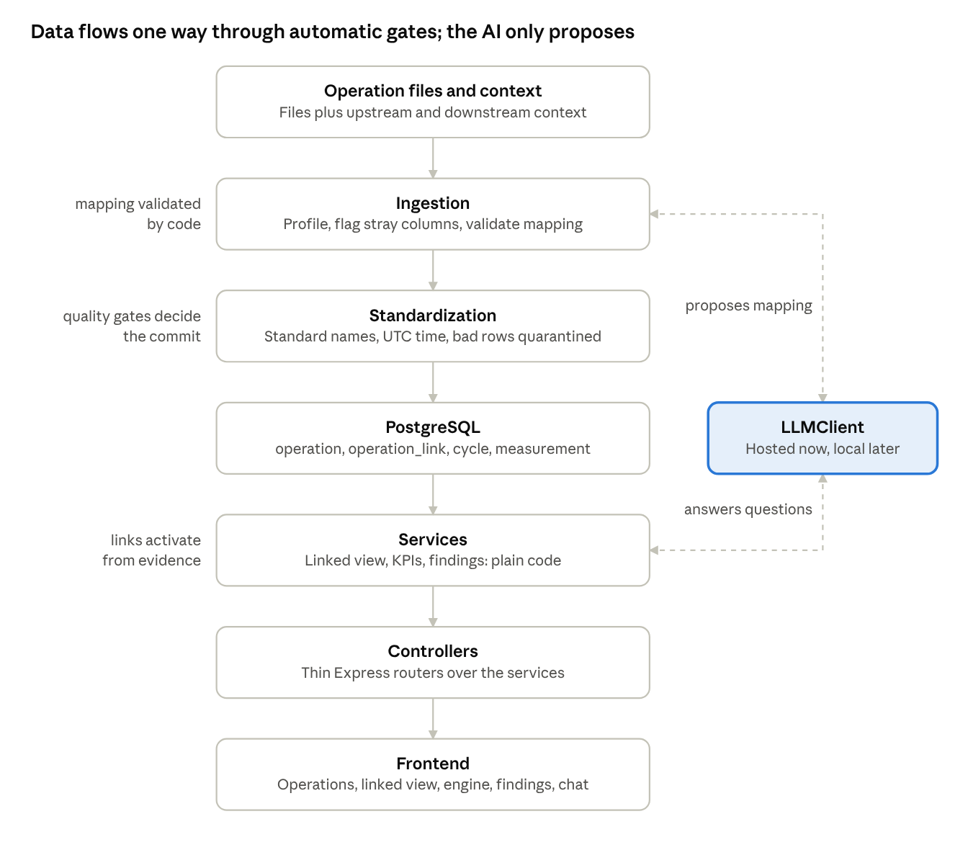
architecture · 7 layers, automatic gates, 1 side service
Operation files, with their context, flow down to the screens through automatic gates and one set of services. The language model sits to the side and never touches the database. Only the first and last steps are file- and screen-specific, so a new operation changes configuration, not code.

4. Tech stack
The stack is TypeScript end to end, so the backend and the React frontend share types and validation schemas. The one gap is statistics: Node has no mature library for Fisher's exact test or the Benjamini–Hochberg correction, so both are written once in the findings service and checked against reference values.
Layer | Choice | Why
Database | PostgreSQL 16 | Reliable on a power cut, supports JSONB for mappings and evidence, views for the linked view
Backend | Node.js 22 LTS, Express 5, TypeScript, Zod | Zod validates requests, mappings and LLM output; types shared with the frontend
Data access | Kysely over node-postgres (no ORM) | Explicit SQL for the joins and rollups
File parsing | ExcelJS, csv-parse | Reads .xlsx and .csv, profiles columns
Statistics | Own TypeScript module, simple-statistics for basics | Fisher's exact test and Benjamini–Hochberg written once and unit-tested against reference values
LLM | Hosted model with tool use, behind one LLMClient interface | Swap for a local model on site without touching other code
Migrations | node-pg-migrate | Versioned schema changes
Frontend | React, TypeScript, Vite, Tailwind | Fast build, typed API client
Charts and graph | Recharts, React Flow | Trends and the operation link graph
Data fetching | TanStack Query | Caching and refresh
Packaging | Docker Compose: db, backend, frontend (nginx) | One command to start, easy to move on site
Tests | Vitest, Supertest, Playwright | Unit tests for KPIs and joins, one end-to-end run

5. Database schema
The schema is generic: an operation is a row, not a table, and each measured value is a row in measurement. Adding a third operation needs no migration. Bolt torques and leak rate land in the same shape.
CREATE TABLE source_file (
file_id BIGSERIAL PRIMARY KEY,
filename TEXT NOT NULL,
sha256 TEXT NOT NULL UNIQUE, -- same file twice = no reload
uploaded_at TIMESTAMPTZ NOT NULL,
row_count INT,
status TEXT NOT NULL -- uploaded | mapped | standardized | loaded | failed
);
CREATE TABLE operation (
operation_id TEXT PRIMARY KEY, -- plant operation number: '10', '20'
name TEXT NOT NULL, -- 'Top Cover Tightening', 'Leak Testing'
mapping JSONB NOT NULL, -- validated column mapping (section 6)
mapping_ver INT NOT NULL DEFAULT 1
);
CREATE TABLE operation_link ( -- from registered context only; evidence computed by code
link_id BIGSERIAL PRIMARY KEY,
upstream_id TEXT NOT NULL REFERENCES operation,
downstream_id TEXT NOT NULL REFERENCES operation,
join_key TEXT NOT NULL DEFAULT 'engine_serial',
source TEXT NOT NULL, -- context
status TEXT NOT NULL, -- active | inactive, set by the evidence checks
overlap_pct NUMERIC, -- share of engines present in both
order_ok_pct NUMERIC, -- share where upstream ends before downstream starts
median_transit_s NUMERIC,
cardinality TEXT, -- one_to_one | one_to_many
evaluated_at TIMESTAMPTZ NOT NULL,
UNIQUE (upstream_id, downstream_id),
CHECK (upstream_id <> downstream_id)
);
CREATE TABLE load_batch ( -- one standardized load, committed by the quality gates
batch_id BIGSERIAL PRIMARY KEY,
file_id BIGINT NOT NULL REFERENCES source_file,
operation_id TEXT NOT NULL REFERENCES operation,
mapping_ver INT NOT NULL,
status TEXT NOT NULL, -- standardizing | committed | held | rolled_back
report JSONB NOT NULL, -- rows read, loaded, duplicates, null serials, quarantined, flagged columns, gate results
committed_at TIMESTAMPTZ
);
CREATE TABLE rejected_row ( -- quarantine: rows that failed a rule
rejected_id BIGSERIAL PRIMARY KEY,
batch_id BIGINT NOT NULL REFERENCES load_batch,
source_record_id TEXT NOT NULL,
reason TEXT NOT NULL, -- 'unparsable_time', 'bad_result', ...
raw JSONB NOT NULL
);
-- stg_cycle and stg_measurement: same columns as cycle and measurement plus batch_id.
-- Standardization writes only here. A batch that passes the quality gates is copied into
-- cycle and measurement in one transaction. A batch that fails them is held.
CREATE TABLE engine (
engine_serial TEXT PRIMARY KEY, -- 'BIZENGM1000001'
first_seen_at TIMESTAMPTZ
);
CREATE TABLE cycle (
cycle_id BIGSERIAL PRIMARY KEY,
operation_id TEXT NOT NULL REFERENCES operation,
engine_serial TEXT REFERENCES engine, -- NULL kept and counted, never dropped
attempt INT NOT NULL DEFAULT 1, -- 1 = first, 2+ = rework / retest
entered_at TIMESTAMPTZ,
started_at TIMESTAMPTZ NOT NULL, -- stored in UTC
ended_at TIMESTAMPTZ,
cycle_time_s NUMERIC, -- computed once by the loader
result TEXT NOT NULL, -- OK | NOK
resource_id TEXT, -- machine, spindle or fixture: 'NUTRUNNER-01'
batch_id BIGINT REFERENCES load_batch,
source_record_id TEXT NOT NULL, -- sheet and row number, or vendor id
UNIQUE (operation_id, source_record_id) -- reload never duplicates
);
CREATE INDEX ON cycle (engine_serial, operation_id, attempt);
CREATE TABLE measurement (
measurement_id BIGSERIAL PRIMARY KEY,
cycle_id BIGINT NOT NULL REFERENCES cycle ON DELETE CASCADE,
parameter TEXT NOT NULL, -- 'bolt1_torque'
value NUMERIC NOT NULL,
unit TEXT, -- 'Nm', 'sccm', 's'
lower_limit NUMERIC,
upper_limit NUMERIC,
is_derived BOOLEAN NOT NULL DEFAULT FALSE
);
CREATE INDEX ON measurement (parameter, cycle_id);
CREATE TABLE finding (
finding_id BIGSERIAL PRIMARY KEY,
target_operation TEXT NOT NULL, -- '20'
target_result TEXT NOT NULL, -- NOK
factor TEXT NOT NULL, -- '10.torque_diff > 2.0'
n_fail_with INT, n_fail_without INT,
n_pass_with INT, n_pass_without INT,
lift NUMERIC,
p_value NUMERIC,
q_value NUMERIC, -- after Benjamini–Hochberg
kind TEXT NOT NULL DEFAULT 'association',
computed_at TIMESTAMPTZ NOT NULL
);
CREATE TABLE analyst_log (
log_id BIGSERIAL PRIMARY KEY,
question TEXT, tools_called JSONB, answer TEXT,
verified BOOLEAN, created_at TIMESTAMPTZ
);
The linked view is not a stored table. It is generated per group of connected operations (section 6) as a database view over cycle and measurement.

Example rows from the sample files
Times are shown in plant time (IST) for readability and stored as UTC. For this synthetic fixture, interpret the zone-free timestamps as Asia/Kolkata. Production files require an explicit IANA source time zone in the registered operation context; confirm it against the plant clock before the first production load.
cycle
operation_id | engine_serial | attempt | resource_id | started_at (IST) | ended_at (IST) | cycle_time_s | result | source
10 | BIZENGM1000001 | 1 | NUTRUNNER-01 | 07:59:20 | 07:59:30 | 10 | NOK | Tightening Station, row 2
10 | BIZENGM1000001 | 2 | NUTRUNNER-01 | 08:00:04 | 08:00:14 | 10 | OK | Tightening Station, row 3
20 | BIZENGM1000001 | 1 | LEAKTEST-01 | 08:02:14 | 08:02:26 | 12 | NOK | Leak Testing Station, row 2
10 | BIZENGM1000002 | 1 | NUTRUNNER-01 | 08:01:25 | 08:01:35 | 10 | OK | Tightening Station, row 4
20 | BIZENGM1000002 | 1 | LEAKTEST-01 | 08:03:35 | 08:03:47 | 12 | NOK | Leak Testing Station, row 3
measurement
engine | operation_id | attempt | parameter | value | unit | limits | derived
BIZENGM1000001 | 10 | 1 | bolt1_torque | 18.94 | Nm | 15–18 | no
BIZENGM1000001 | 10 | 1 | bolt2_torque | 14.39 | Nm | 15–18 | no
BIZENGM1000001 | 10 | 2 | bolt1_torque | 17.85 | Nm | 15–18 | no
BIZENGM1000001 | 10 | 2 | bolt2_torque | 15.21 | Nm | 15–18 | no
BIZENGM1000001 | 10 | 2 | torque_diff | 2.64 | Nm |  | yes
BIZENGM1000001 | 20 | 1 | leak_rate | 6.21 | sccm | up to 5 | no
BIZENGM1000002 | 10 | 1 | entry_delay_s | 25 | s |  | yes
BIZENGM1000002 | 20 | 1 | leak_rate | 7.23 | sccm | up to 5 | no
Engine BIZENGM1000001 is the rework case: attempt 1 is out of range on both bolts (18.94 and 14.39 Nm) and attempt 2 passes (17.85 and 15.21 Nm). Its torque difference of 2.64 Nm is above the 2.0 Nm indicator, and it then fails the leak test at 6.21 sccm. Engine BIZENGM1000002 passed tightening first time but started 25 s after station entry, and its leak rate is 7.23 sccm.
operation_link
upstream | downstream | join key | source | overlap | order ok | median transit | cardinality | status
10 Top Cover Tightening | 20 Leak Testing | engine_serial | context file | 3,000 of 3,000 engines | 3,000 of 3,000 | 120 s | one to many (2 attempts for 90 engines) | active
finding (what the platform should rediscover from the 30-day file)
target | factor | kind | expected in the 30-day file
operation 20 NOK | operation 10 torque_diff above about 2.0 Nm | association | 360 failures
operation 20 NOK | operation 10 entry_delay_s above about 15 s | association | 300 failures
operation 20 NOK | no upstream factor | unexplained | 60 failures

6. Operations, links, standardization and the linked view
Four artefacts, all produced and checked by code: the context and links, a mapping per operation, a standardized batch of data, and the linked view generated from them. No step waits for a person.

Step 1: Context and links
A versioned operations.yaml is registered once per line and referenced by each upload. It names each operation, its upstream and downstream operations, and its source time zone. It is configuration, not a review step. For linking and mapping, it:
- It decides which operations are joined in the linked view.
- It fixes the direction of impact analysis. An upstream operation is tested only as a possible influence on a downstream result, never the other way round.
- It gives the AI context for a better mapping, for example that operation 20 is judged against measurements from operation 10.
operations:
- id: "10"
name: Top Cover Tightening
timezone: Asia/Kolkata
upstream: []
downstream: ["20"]
- id: "20"
name: Leak Testing
timezone: Asia/Kolkata
upstream: ["10"]
downstream: []
A production upload without a valid registered context version is held with a context_missing or context_invalid report. Operation numbers can suggest a link during profiling, but a suggestion never activates a production link. Code evaluates each configured link against the data. A link becomes active only when all evidence checks pass; otherwise it stays inactive with the failing check recorded. Evidence is recomputed after every committed batch.
- Key overlap. Share of engine serials found in both operations. Pass at 90% or more. In the 30-day file: 3,000 of 3,000.
- Time order. Share of engines where the upstream cycle ends before the downstream cycle starts. Pass at 95% or more. In the 30-day file: 3,000 of 3,000.
- Cardinality. One upstream record per engine, or several because of rework. Recorded, not a pass or fail. In the 30-day file, 90 engines have two tightening attempts.
- Transfer time. Median and spread of the gap from the end of the final upstream cycle to downstream entry. Recorded, not a pass or fail. In the 30-day file: median 120 s, longest about 30 minutes.
The thresholds live in config.

Step 2: Map automatically
The AI reads the column headers, about 5 sample rows and the context, then proposes this JSON. Code validates it against the whole file and applies it only if every check passes. The time zone is copied from registered context and cannot be chosen by the AI. The validated mapping is stored, with a version number, in operation.mapping.
{
"operation_id": "10",
"name": "Top Cover Tightening",
"operation_check": { "column": "Operation Number", "must_equal": 10 },
"sheet": "Tightening Station",
"engine_key": "Engine No",
"attempt": "Attempt",
"resource": "Machine ID",
"entered_at": "Station Entry Time",
"started_at": "Cycle Start Time",
"ended_at": "Cycle End Time",
"timezone": "Asia/Kolkata",
"result": { "column": "Torque Station Result", "ok": ["OK"], "nok": ["NOK"] },
"measurements": [
{ "column": "Bolt 1 Torque (Nm)", "parameter": "bolt1_torque", "unit": "Nm",
"lower_col": "Torque Lower Limit (Nm)", "upper_col": "Torque Upper Limit (Nm)" },
{ "column": "Bolt 2 Torque (Nm)", "parameter": "bolt2_torque", "unit": "Nm",
"lower_col": "Torque Lower Limit (Nm)", "upper_col": "Torque Upper Limit (Nm)" }
],
"derived": [
{ "parameter": "torque_diff", "unit": "Nm", "expr": "abs(bolt1_torque - bolt2_torque)" },
{ "parameter": "entry_delay_s", "unit": "s", "expr": "seconds(started_at - entered_at)" }
],
"checks": [ { "column": "Cycle Duration (sec)", "equals": "seconds(ended_at - started_at)" } ],
"ignore": ["Station", "Unnamed: 14", "Unnamed: 15"]
}
The leak-test mapping has the same shape: operation 20, sheet "Leak Testing Station", the same engine key and machine column, one measurement leak_rate in sccm with its upper limit from "Leak Threshold (sccm)", and the result from "Leak Test Result". It has no attempt column, so attempt defaults to 1. The answer columns on the Linked View sheet are never mapped.
Validation before a mapping is applied
- The proposal matches the schema: every required field is present and every named column exists in the sheet, and its time zone matches registered context.
- A dry run over the whole file parses at least 99% of times, numbers and results, and reproduces the row count.
- Results contain only the values mapped to OK or NOK.
- The result agrees with the limits in at least 99% of rows.
- Where the file has its own duration column, it equals end minus start in at least 99% of rows.
- Engine serials follow one pattern.
If a check fails, the errors go back to the AI for up to two more proposals. If none passes, the file is marked failed with its report and nothing is loaded.

Step 3: Standardize and commit
After the mapping is applied, the loader standardizes the file into staging tables and writes a batch report. Nothing reaches cycle or measurement until the batch passes the quality gates.
- Names. Each column becomes a standard parameter code from the mapping, with an explicit unit.
- Time. Parsed using the explicit IANA source time zone from the registered context, checked against the applied mapping, and stored in UTC. A missing or invalid zone holds the upload; unparsable row values are rejected and listed.
- Result. Mapped to OK or NOK only. Any other value is rejected and listed. A result that disagrees with its limits is logged as result_mismatch and never relabelled.
- Engine serial. Trimmed and upper-cased. A blank serial is kept as null and counted.
- Attempt. From the mapped column, otherwise 1.
- Cycle time. cycle_time_s is computed once from start and end, and checked against the file's own duration column when one is mapped.
- Derived parameters such as torque_diff and entry_delay_s are computed from the mapping's expressions and stored with is_derived = true.
- Duplicates. Skipped by file hash and by (operation_id, source_record_id).
- Unmapped columns that hold data are listed, such as the two untitled columns with a stray character in row 8 of the tightening sheet.
Quality gates. The batch commits in one transaction when at least 99% of rows pass the rules and null serials are under 1%. Otherwise it is held and nothing is loaded. Rows that fail a rule go to the rejected_row quarantine table with the reason. The batch report shows rows read, standardized, quarantined, null serials, mismatches and flagged columns. An administrator can roll back a committed batch.

Step 4: Rules for generating the linked view
A group is a set of operations connected by active links. Each group gets one generated view.
- No link, no join. Only active links produce a join. An operation with none stays standalone and gets its own view.
- Join key. engine_serial, matched exactly after standardization. Rows with a null serial never join.
- One row per engine per group. The first block comes from the most upstream operation. Several upstream or downstream operations each add a block of columns.
- Keep missing engines. Use LEFT JOIN from the engine table, so an engine missing downstream stays visible with empty columns.
- Rework. Show the number of attempts, the first-attempt result and the final result. Measurements and machine come from the final successful attempt, the one that released the engine downstream, and impact analysis uses those values.
- Transfer time. Downstream entry minus the end of the final successful upstream attempt. A negative value is flagged as an order failure and never dropped.
- Machines. The resource_id of every operation is carried as a column.
- Stable names. Columns follow op<operation_id>_<parameter>, for example op10_bolt1_torque, so adding an operation never renames an existing column.
- No new calculations. Derived values come from measurement. The view adds only the transfer time.
- No answer columns. Conclusions that arrive inside a source file are never generated.
- Regeneration. The view is rebuilt when a mapping, an active link or a committed batch changes.
CREATE VIEW linked_view_g1 AS
WITH op10 AS (
SELECT c.engine_serial, c.attempt, c.resource_id, c.started_at, c.ended_at, c.result,
max(m.value) FILTER (WHERE m.parameter='bolt1_torque') AS bolt1_torque,
max(m.value) FILTER (WHERE m.parameter='bolt2_torque') AS bolt2_torque,
max(m.value) FILTER (WHERE m.parameter='torque_diff') AS torque_diff,
max(m.value) FILTER (WHERE m.parameter='entry_delay_s') AS entry_delay_s
FROM cycle c JOIN measurement m USING (cycle_id)
WHERE c.operation_id = '10' GROUP BY c.cycle_id),
op20 AS (
SELECT c.engine_serial, c.attempt, c.resource_id, c.entered_at, c.result,
max(m.value) FILTER (WHERE m.parameter='leak_rate') AS leak_rate
FROM cycle c JOIN measurement m USING (cycle_id)
WHERE c.operation_id = '20' GROUP BY c.cycle_id)
SELECT e.engine_serial,
n.attempts AS op10_attempts,
a1.result AS op10_result_first,
af.result AS op10_result_final,
af.resource_id AS op10_machine,
af.bolt1_torque AS op10_bolt1_torque,
af.bolt2_torque AS op10_bolt2_torque,
af.torque_diff AS op10_torque_diff,
af.entry_delay_s AS op10_entry_delay_s,
l.resource_id AS op20_machine,
l.leak_rate AS op20_leak_rate,
l.result AS op20_result,
l.entered_at - af.ended_at AS transfer_time
FROM engine e
LEFT JOIN LATERAL (SELECT count(*) AS attempts FROM op10 t
WHERE t.engine_serial = e.engine_serial) n ON TRUE
LEFT JOIN op10 a1 ON a1.engine_serial = e.engine_serial AND a1.attempt = 1
LEFT JOIN LATERAL (SELECT * FROM op10 t WHERE t.engine_serial = e.engine_serial AND t.result = 'OK'
ORDER BY t.attempt DESC LIMIT 1) af ON TRUE
LEFT JOIN op20 l ON l.engine_serial = e.engine_serial AND l.attempt = 1;
For the 30-day file the view must match the file's Linked View sheet row for row, apart from the answer columns, which are never generated.

7. Controllers (REST API)
Controllers are Express routers under /api/v1. Each one validates the request with a Zod schema, calls one service function and returns a typed response. No SQL and no business rules live in a controller. Time ranges accept a preset (today, yesterday, last_7_days) or from and to in ISO 8601, and list endpoints are paginated.
router.post('/files', upload.single('file'), async (req, res) => {
const body = UploadBody.parse(req.body); // Zod validates the input
const job = await ingestionService.start(req.file, body.context); // runs the whole pipeline as a job
res.status(202).json({ jobId: job.id }); // Express 5 forwards rejected promises to the error middleware
});
Controller | Method and path | What it does
Files | POST /files | Upload an .xlsx or .csv referencing a registered context version; the first upload may register operations.yaml. Starts the automatic pipeline (profile, map, validate, standardize, commit) as a job and returns the job id
Files | GET /files/{id} | Pipeline status and the batch report
Batches | GET /batches/{id} | Report, quality-gate results and quarantined rows
Batches | POST /batches/{id}/rollback | Admin only: undo a committed batch
Operations | GET /operations | All operations with KPIs, last data time and link status
Operations | GET /operations/{id} | KPIs, per-parameter statistics, per-machine OK rate
Operations | GET /operations/{id}/mapping | The applied mapping and its validation results, read-only
Operations | GET /operations/{id}/trend?parameter=&period= | Time series with reference band
Links | GET /links | All links, active or inactive, with their evidence
Groups | GET /groups | Connected groups of operations, in line order
Linked view | GET /groups/{id}/view?period=&result=&cursor= | Rows of the linked view, filterable, paginated
Linked view | GET /engines/{serial} | One engine across every operation, attempts included
Insights | POST /groups/{id}/findings/run | Body: target operation and result. Computes and stores associations along active links
Insights | GET /groups/{id}/findings | Stored findings, ranked
Analyst | POST /analyst/query | Question in, streamed steps and a verified answer out
Admin | POST /admin/rebuild-views and /admin/reevaluate-links | Regenerate the linked views, or recompute every link's evidence
Conventions
- Every number returned carries its unit, period and data coverage, so the screen and the analyst can quote the same value.
- Errors use one shape, produced by a single Express error middleware, with a code and a message, for example mapping_invalid, file_already_loaded, link_not_active.
- Long steps (a load, a findings run) return a job id and a status endpoint instead of holding the request open. Jobs run on a pg-boss queue, which stores them in PostgreSQL, so no extra container is needed.

8. Services
All business logic sits in plain TypeScript services. Controllers, the analyst tools and the command line call the same functions, so a number on screen always equals the number the analyst quotes. Only two services ever call the LLM: mapping and the analyst.
packages/shared/ Zod schemas and TypeScript types used by backend and frontend
backend/src/
routes/ controllers (Express routers)
services/
ingestion.ts mapping.ts linking.ts linkedView.ts
kpi.ts findings.ts periods.ts
analyst/ orchestrator.ts tools.ts validate.ts
stats/ fisher.ts benjaminiHochberg.ts
ai/ llmClient.ts (the only file that imports the provider SDK)
repositories/ SQL, one module per table group (Kysely)
jobs/ pg-boss workers for loads and findings runs
cli.ts seed, rebuildViews, runFindings
frontend/src/ React app
Service | Owns | Key functions | Calls LLM
IngestionService | The pipeline: profiling columns, standardizing into staging, quality gates, committing or holding batches, rollback | start(file, context), standardize(fileId, mapping), commitIfPassing(batchId), rollback(batchId) | No
MappingService | Proposing, validating and applying an operation mapping | propose(fileId, context), validate(mapping, fileId), apply(operationId, mapping) | Yes, proposal only
LinkService | Loading versioned operation context, evaluating configured links against evidence, activating or deactivating links | loadContext(context), evaluate(upstreamId, downstreamId) | No
LinkedViewService | Groups, generating and querying views | groups(), regenerate(groupId), query(groupId, filters) | No
KpiService | OK rate, first-pass yield, cycle time, data coverage | operationKpis(operationId, period) | No
FindingsService | Association tests between upstream factors and a downstream result | run(groupId, targetOperation, result, period) | No
PeriodService | UTC storage, shift assignment, period presets | assignShift(ts), resolve(preset) | No
AnalystService | Tool loop, evidence ids, validation | answer(question, context) | Yes
Rules the loader enforces
- Timestamps are converted to UTC once, in the loader, using the registered context's IANA time zone; the mapping must agree with it.
- cycle_time_s is computed once at load, never in SQL.
- A row with no usable engine serial is kept with a null serial and counted in the load report. It is never dropped and never joined by guess.
- Reloading the same file creates no duplicates, because of the (operation_id, source_record_id) uniqueness and the file hash.
- Derived parameters such as torque_diff are computed from the mapping's expressions, stored with is_derived = true, and recomputed if the mapping changes.
How FindingsService.run works
- Take every engine with an attempt-1 result at the target operation in the period, and label it failing or passing.
- Build candidate factors only from operations upstream of the target along active links, using the upstream attempt that released the engine downstream (the final successful one): numeric parameters cut at specification limits, configured engineering indicators, and reference-window quantiles (for example the 90th and 95th percentile), plus categorical ones such as resource or shift. The sample indicators are torque_diff > 2.0 Nm and entry_delay_s > 15 s. Choose cut-points without looking at the target outcomes.
- Test each factor level with at least 5 exposed engines and at least 5 unexposed engines. Compute the four outcome counts, failure-rate lift and Fisher's exact p. A zero passing count is valid and must not exclude a level. Define lift as exposed failure rate divided by unexposed failure rate; report it as undefined when the denominator is zero, while retaining the counts and p-value.
- Apply Benjamini–Hochberg across every tested level, including all eligible cut-points, to control false discoveries from multiple comparisons.
- Keep levels with q below 0.05 and at least 10 failing engines. Store them as kind = association.
- Report the share of failures left unexplained by any kept factor. This is the "unexplained" group.

9. AI layer
The AI does three jobs. In none of them does it touch the database, run SQL or compute a number. It returns structured output that code validates. A mapping is applied only if every check passes, and no person approves anything.
Job | Sees | Returns | Checked by
Mapping proposer | Column headers, about 5 sample rows and the operation context | Mapping JSON | Zod schema, then a dry run over the whole file. A failing proposal goes back to the AI up to twice, then the file is marked failed
Insight explainer | Stored findings only | Plain-language explanation | Number and citation validator. Shown with a badge
Analyst chat | The user's question and tool results | Answer with evidence ids | Same validator. Shown with a badge
Analyst tools. The chat can only call approved tools, each a thin wrapper over a service function:
- list_operations, get_operation_kpis, get_trend
- list_links, get_groups
- query_linked_view with structured filters such as operation, result and period. It never accepts free SQL.
- get_findings, run_findings
- get_engine_history
Trust rules. These come from the Plant Intelligence design and carry over unchanged.
- Answer only from tool results. If no tool can answer, say so.
- Cite an evidence id (E1, E2 and so on) on every sentence with a number, date, operation or engine serial.
- Write "associated with", never "caused by". Suggest what an engineer could check to confirm a cause.
- State the data caveat when coverage is low or when failures are left unexplained.
- Say "first-attempt" or "final" next to every pass or fail figure.
- Every answer goes through validate.ts, which checks numbers, dates, identifiers and citations against the cited results. The answer carries a Verified against plant data or Not verified badge. There is no silent retry.
Evaluation. Keep a list of 10 test questions about the sample data, 2 of them unanswerable. A prompt or model change passes only if the answers stay correct. Examples: "Which upstream measurement is linked to leak failures?" should name torque difference and start delay. "Which operator caused the failures?" has no data behind it and must be declined.
Provider. The LLM sits behind one LLMClient interface with the provider, model and key read from .env. This keeps the later move to a local model on the client's server a configuration change plus re-running the evaluation.

10. Frontend
The interface is desktop-first. Ingestion runs by itself, so the screens are for reading the data and checking what the pipeline did. A chat panel is available on every screen, with option buttons under each answer. Every screen shows a small "Synthetic data" label while sample data is loaded.
Screen | What it shows | Key interaction
Operations (home) | A card per operation with OK rate, last data time and link status, beside a graph of links | Click a card; click a link to see its evidence
Upload | Register operations.yaml once, then drop a file under its context version and watch the pipeline status | Nothing after the drop: the pipeline runs by itself
Mapping and batch report | The applied mapping with its validation results, plus rows read, standardized, quarantined, null serials and flagged columns | Read-only; open the quarantined rows
Links | Each link active or inactive, with its evidence | Read-only
Linked view | One row per engine, column groups per operation, out-of-range cells marked | Filter by result or period; click a row
Engine | One engine across every operation, attempts and transfer times, values against limits | Switch between first and final attempt
Findings | Ranked associations with the counts behind each, and the share of failures left unexplained | "Ask the analyst about this"
Chat panel | Streamed steps, the answer, a Verified or Not-verified badge, evidence cards, option buttons | Option buttons call one tool directly, with no LLM wait
Key components: OperationCard, LinkGraph (React Flow), MappingTable, LinkEvidenceCard, LinkedTable with grouped headers, EngineTimeline, FindingCard, ChatPanel, VerifiedBadge.
Design rules. One accent colour. Red, amber and green only for status. "First-attempt" and "final" are always labelled, so two similar figures are never confused. An operation with no active link is shown as standalone, never hidden.

11. Build plan
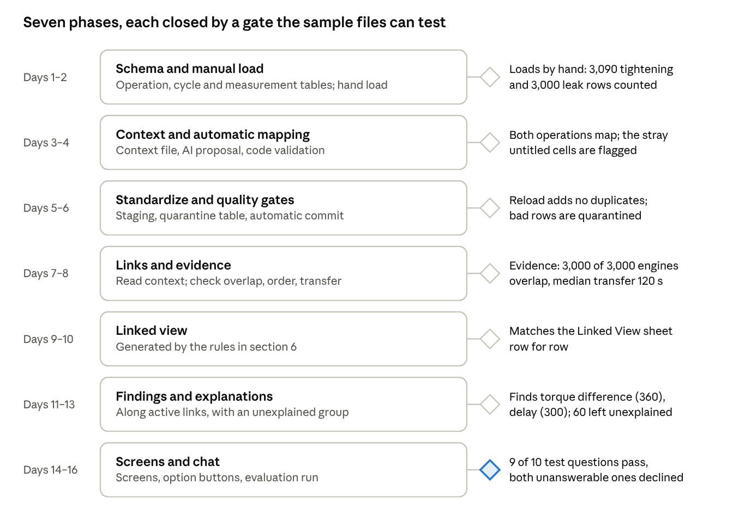
build plan · 7 phases, 7 gates
The days are a target of 16 working days for one engineer, not a commitment, and the phases are not drawn to scale. A phase is done only when its gate passes on the 30-day file. Phase 1 starts with a plain script on purpose: it shows exactly what the mapping in phase 2 has to produce.

12. Risks and decisions
The biggest risk is a wrong setup that still looks plausible: a mis-mapped column or a false link produces tidy but wrong numbers. That is why every mapping goes through a dry-run check over the whole file and every link must pass an evidence check.
Risk | What happens | Mitigation
Wrong column mapping | Torque loaded as the wrong parameter, limits swapped | Validation over the whole file: parse rates, result values, results against limits, duration check, row count. A failing proposal goes back to the AI up to twice, then the file is marked failed and nothing loads
A wrong mapping that passes every check | Plausible but wrong numbers reach the views | The mapping version is stored with every batch, so a batch can be rolled back and reloaded. Totals are reconciled against the source file's own summary where it has one
Wrong or missing context | Wrong operations joined, or no join | A missing or invalid registered context holds the upload. Configured links activate only after overlap and time-order checks pass. Reversed direction fails the order check and remains inactive
Bad data committed | Stray values or rejected rows slip into the data | Quality gates: 99% of rows must pass and null serials stay under 1%. Rejected rows go to a quarantine table with reasons. A failing batch is held, not committed
Stray or untitled columns | Junk values, like the stray character in row 8 of the tightening sheet | The profiler flags every unmapped column that holds data, and the batch report lists it
Spurious findings | Cut-points tuned to the data look significant | Multiple-testing correction over every level tested, minimum failing count, wording "association"
Time zones and clock drift | Order check fails or transfer times are negative | Require an IANA source time zone in registered context, verify it before production loading, and match the mapping to it. Record any known per-operation clock offset and flag engines that fail the order check
Missing or duplicate serials | Engines drop out of the linked view or double count | Null serials kept and counted, unique source ids, batch report on every upload
Different file layouts | Each new operation needs a new mapping | The AI drafts it and code validates it, so there is no per-operation manual work
One machine per operation | Machine ranking cannot be tested | Add a second machine to the test data before building the machine view
Growth beyond sample size | Views slow down with months of data | Index on (engine_serial, operation_id, attempt), materialize the linked view and refresh after committed batches
Power loss on the client server | Partial load, possible data loss | UPS with clean shutdown, PostgreSQL write-ahead logging, each batch commits in one transaction, scheduled backups
Network drop between operations and server | Gaps look like a calm line | Keep a per-operation last-data time, show a data-gap banner, reload the missed file safely
No cloud LLM on site | Automatic mapping unavailable | LLMClient swap to a local model, re-run the evaluation. As a fallback, a mapping file kept in config goes through the same validation
Decisions for the first version and deployment checks
- Synthetic fixture: interpret its zone-free timestamps as Asia/Kolkata. Production: require the source time zone in operations.yaml and verify it with the plant before the first load; do not infer it from a machine timestamp.
- First version: ingest .xlsx and .csv files. If the plant later supplies a vendor server or database feed, add an ingestion adapter behind the same profiling, validation, and quality gates.
- First version: one line, with operation numbers unique within that line. Before a second line is loaded, namespace operation_id by line and update context and view names; never merge reused operation numbers.
- Context source: register a versioned operations.yaml once per line and reference it on every upload. It supplies operation links and source time zones. Missing context holds production uploads; operation-number inference may be shown as a diagnostic suggestion but cannot activate a link.
- Mapping policy: preserve the no-approval pipeline. Keep full-file validation, quality gates, mapping and context versions on every batch, source-summary reconciliation when available, a visible audit report, and an administrator rollback. A failed check holds the batch.
- Statistics policy: keep Fisher's exact test and Benjamini–Hochberg in the TypeScript findings service for the first version. Test against independent reference values, including zero-cell tables, and test the sample gate: 360 torque cases, 300 delay cases, and 60 unexplained failures.

